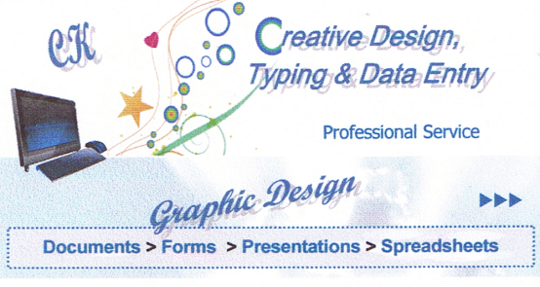
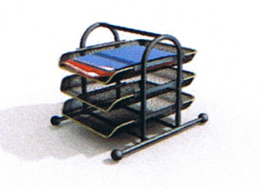

Professional Typing
& Custom Design Service

Creative Keyboarding Typing & Design www.creativekeyboarding.com
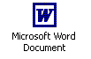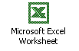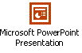

Typing & Creative Design

Matteson, IL 60443

708-720-1487 (P)
708-720-5211 (F)

info@creativekeyboarding.com

The Ideal Service for All Your Typing & Design Needs

We Offer Online & Offline Order Forms, Samples, and Payments
Quantity Discounts & Regular Customer Discounts
.
Resume & Letters
• Curriculum Vitae
• Resume
• Cover Letter
• Follow-up Letter
• Thank You Letter
• Letter of Intent

Publications
• Book
• Directory
• Manual
• Manuscript
• Thesis

Personal Documents
• Life Story
• Poems
• Recipes

- Accurate Documents
- Attractive Design
- Clip Art / Word Art
- Your Preferred Styles
- Over 25 Years Experience

Documents & Design
• Advertisements
• Announcements
• Brochures
• Documents
• Flyers
• Form Letters
• Letters
• Newsletters
• Outlines
• Reports
• Term Papers

Stationary Design
• Fax
• Memo
• Letterhead

Special Projects
• Chart / Diagram
• Form / Table
• Excel Spreadsheets
• PowerPoint Presentations

Custom Business Design
• Business Cards/Postcards
• Business Forms / Flyers
• Restaurant Menus/Inserts

Custom Personal Design
• Custom Personal Letter
• Greeting Card/Invitation
• Family Tree

Website Design

Type Revise Design
Educational Professional Personal

